## IMDB Movie Analysis

**PROJECT DESCRIPTION :-**

The IMDb Movie Analysis project aims to explore and analyze a comprehensive dataset of movies available on the IMDb platform. This dataset contains essential information about movies, including director names, movie titles, duration, genre, budget, gross earnings, IMDb ratings, and more. Through in-depth data analysis using Excel, Data Visualization and Statistics techniques this project seeks to extract valuable insights and trends that contribute to a movie's success.

**APPROACH :-**

1. **Movie Genre Analysis:**

**Task:** Determine the most common genres of movies in the dataset. Then, for each genre, calculate descriptive statistics (mean, median, mode, range, variance, standard deviation) of the IMDB scores.

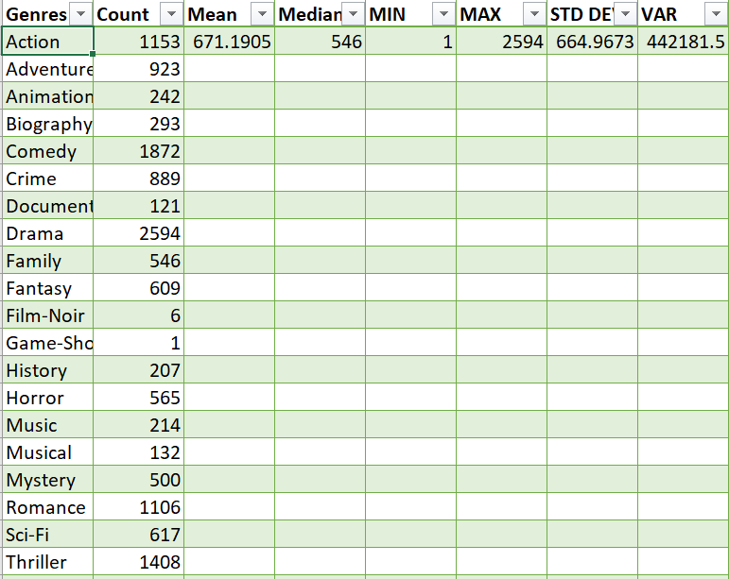

1. **Movie Duration Analysis:**

**Task:** Analyze the distribution of movie durations and identify the relationship between movie duration and IMDB score.

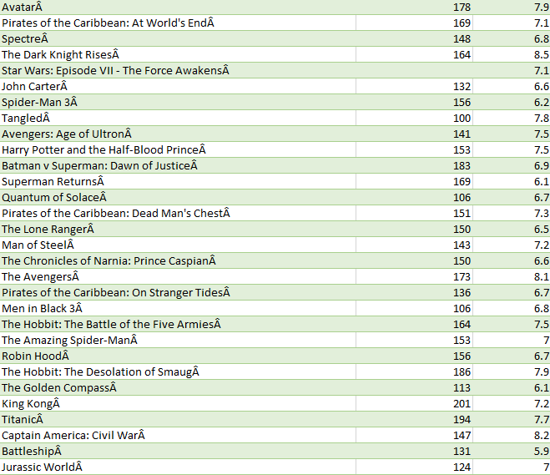

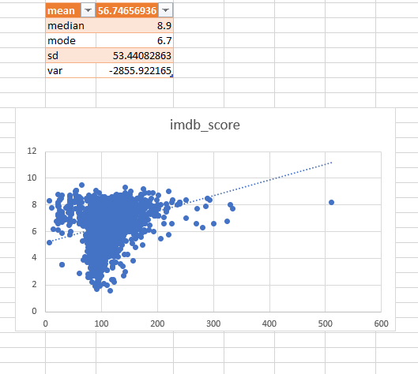

1. **Movie Language Analysis:**

**Task:** Determine the most common languages used in movies and analyze their impact on the IMDB score using descriptive statistics.

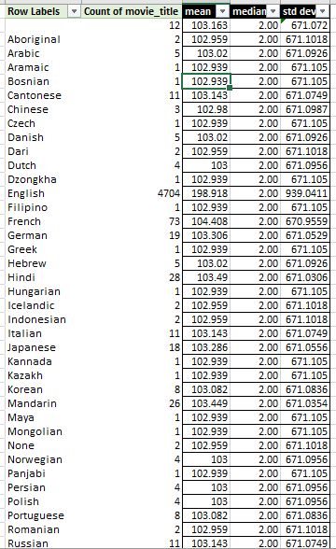

1. **Movie Director Analysis:**

**Task:** Identify the top directors based on their average IMDB score and analyze their contribution to the success of movies using percentile calculations.

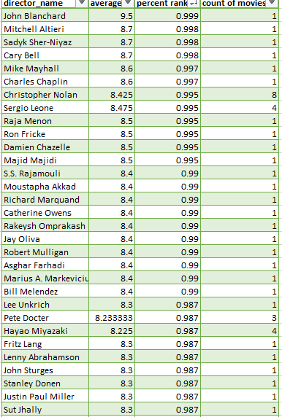

1. **Movie Budget Analysis:**

**Task:** Analyze the correlation between movie budgets and gross earnings, and identify the movies with the highest profit margin.

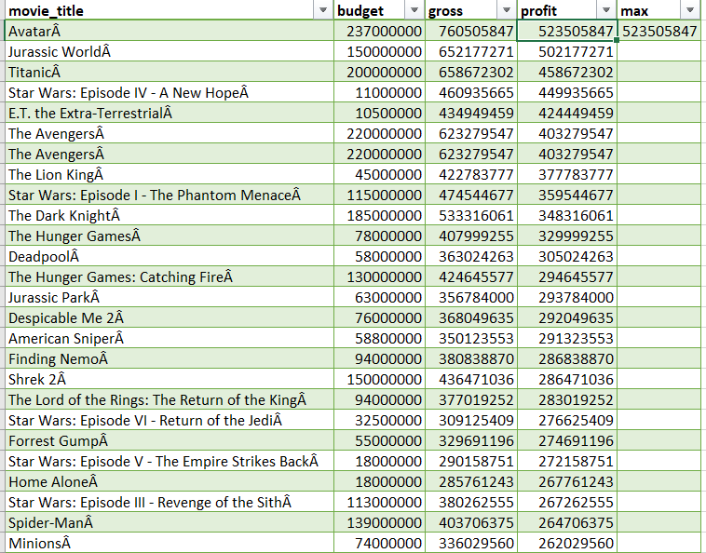

I have noticed that,

1. The Most common movie genres from the dataset are Drama, Comedy, Thriller and Action.
2. The Average duration of a Movie is 109 minutes. The trendline between the duration vs imdb score is elevated upward with R^2 = 0.131
3. The Most common languages used in the movies are English, French, Spanish, Mandarin and German. I have also Observed that the languages Telugu and Persian have the highest average imdb score.
4. I have identified that Tony Kaye, Charles Chaplin, Alfred Hitchcock, Ron Fricke, Damien Chazelle, Majid Majidi, Sergio Leone, Christopher Nolan, SS Rajamouli and Richard Marquand are the top 10 directors with average imdb score >=8.4
5. The Top-5 with highest profits are Avatar, Jurassic World, Titanic, Star Wars: Episode IV - A New Hope and E.T. The Extra-Terrestrial. The Correlation between budget and gross is positive.

**TECH-STACK USED:**

Microsoft Excel 2019

<https://docs.google.com/spreadsheets/d/1eXprVVzU9CiXAe6MJHr_9tuGkbcGCeuL/edit?usp=sharing&ouid=110001160656720096453&rtpof=true&sd=true>

**RESULTS :-**

With the help of this project, I have gained valuable experience for data analysis using statistical knowledge and excel’s data visualization. Through this, I have learnt to apply my data analysis skills in solving real life problems.